**Project 1**

**Scenario :** Create Amazon Dynamo DB Table using default table setting. The table name must be “Student” and the Partition key must be “rollno” – Number Type. Add these items in the table “Student.”

Rollno(Number) Name(String)

20 Amit

30 Anil

40 Aman

Query the rollnumber 20 and Delete the Amazon Dynamo DB Table “Student.”

**Solution:**

**Step 1:** Open AWS management console, click on Services. Go to Database section and click on DynamoDB. The following window will appear. Click on Create table as shown below.

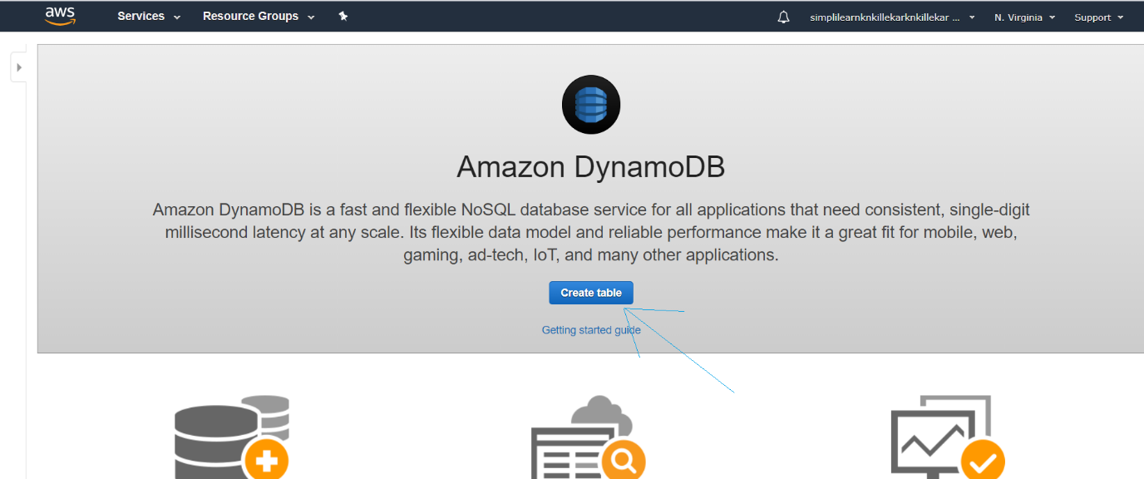

**Step 2:** Now enter the Table name as “Student” and Partition key as “rollno” (Number) as shown in the window below. Then click on Create option.

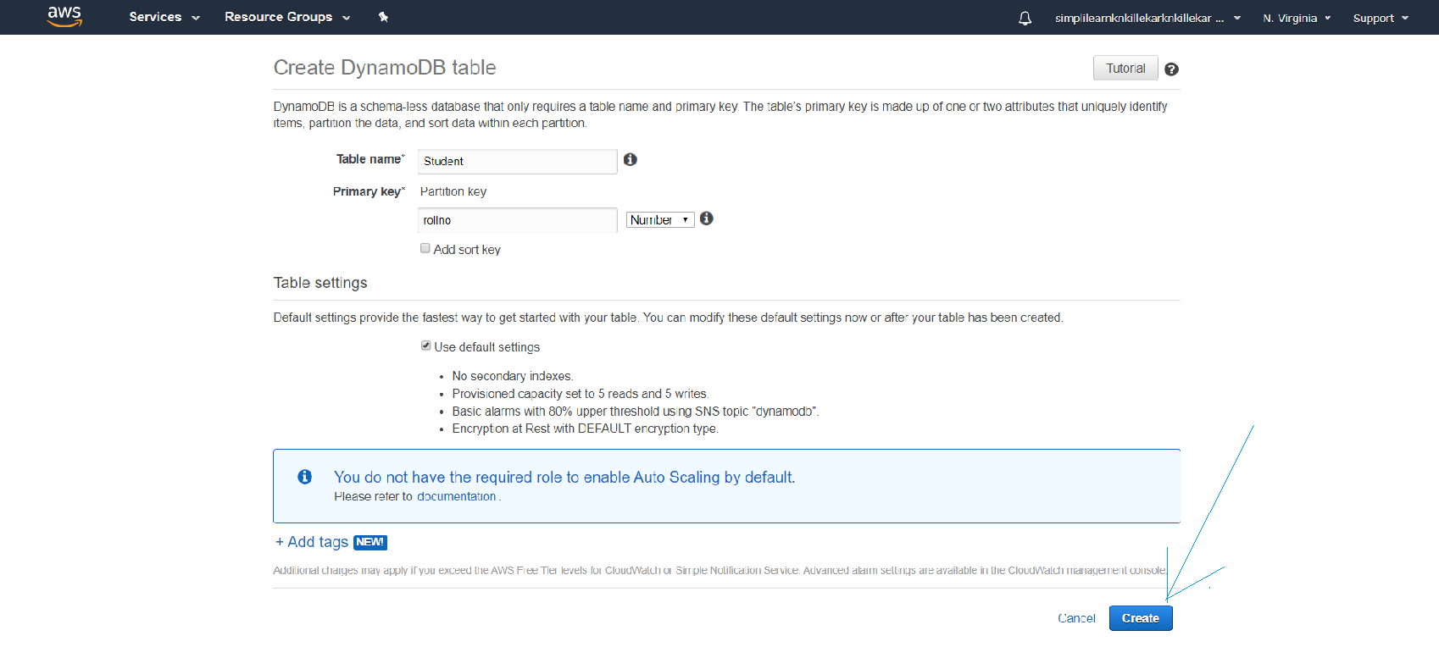

**Step 3:** Next click on items in Student table as shown below.

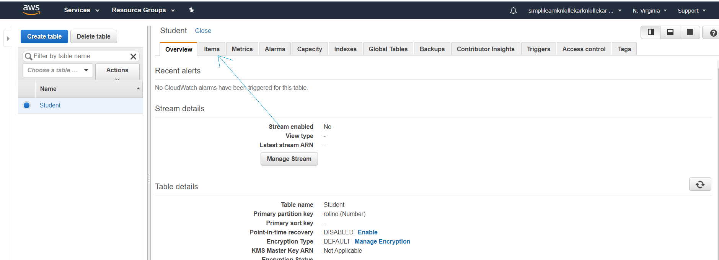

**Step 4:** After selecting items tab, the following window will appear. Now click on Create item as shown below.

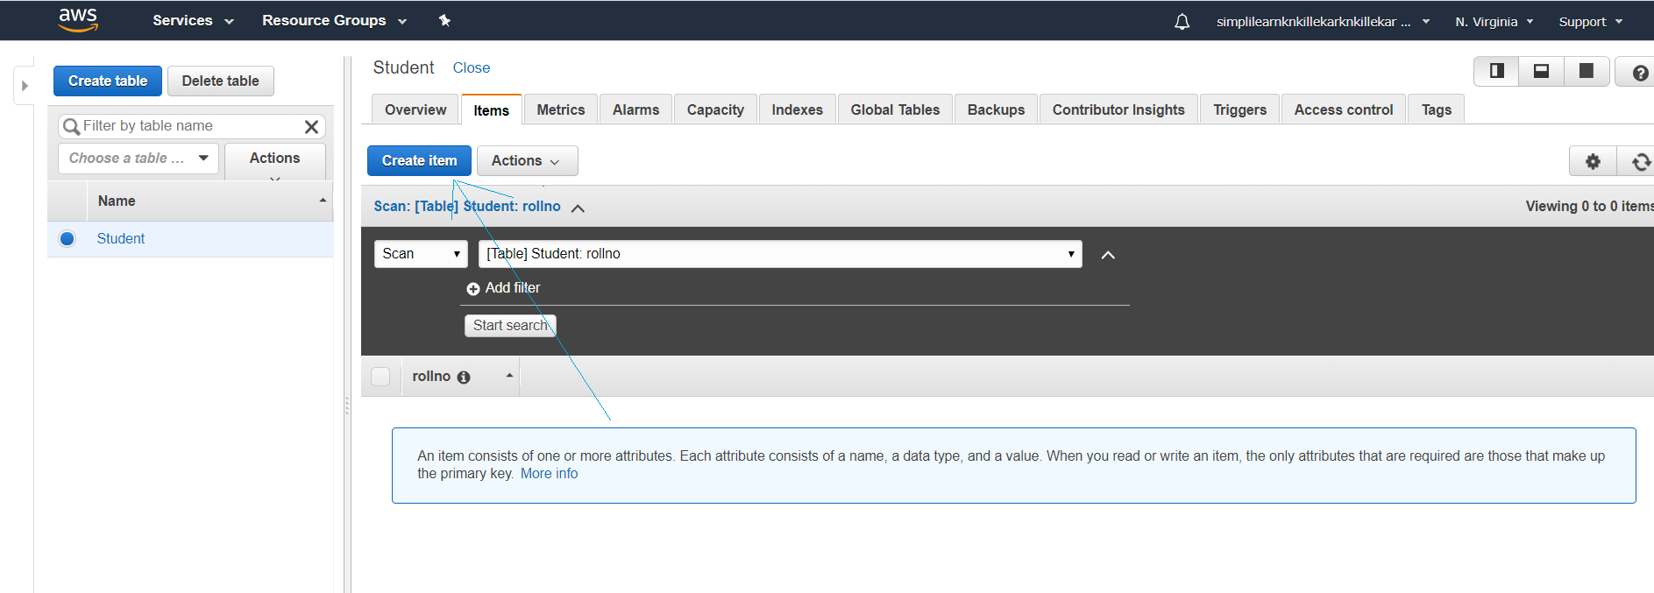

**Step 5:** After selecting Create item, the Create item window will open. In this window enter the following details as shown below. After entering the details, click on save option.

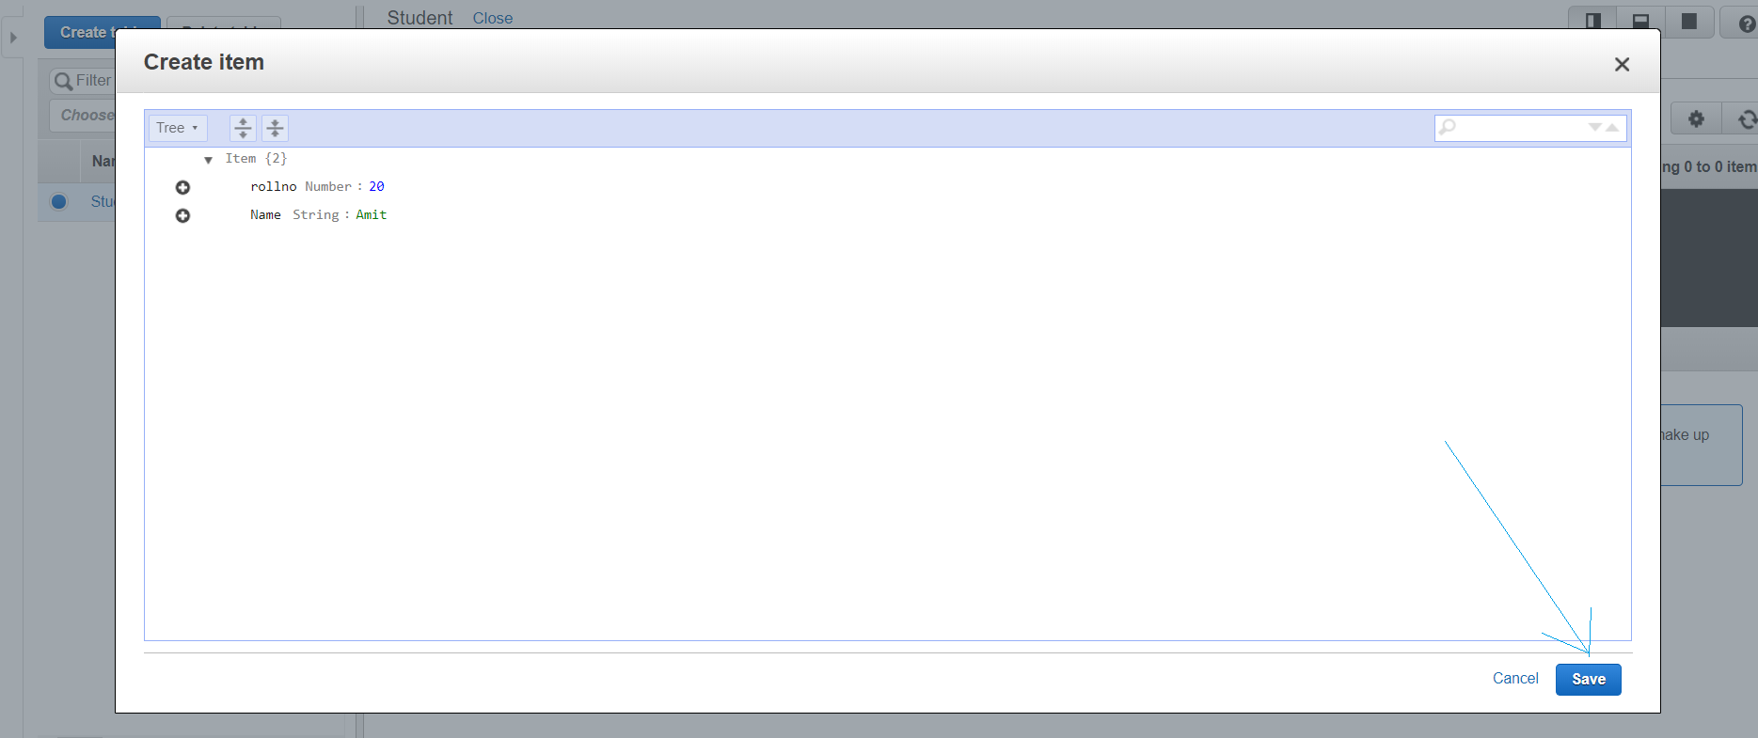

**Step 6:** Repeat the step 5 to add the other two next items as shown in the following windows.

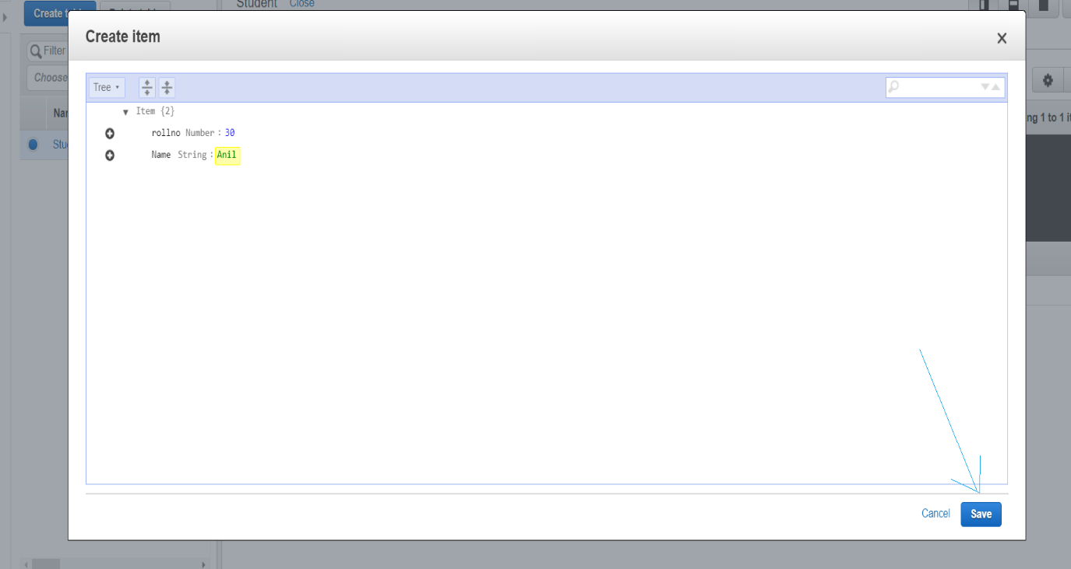

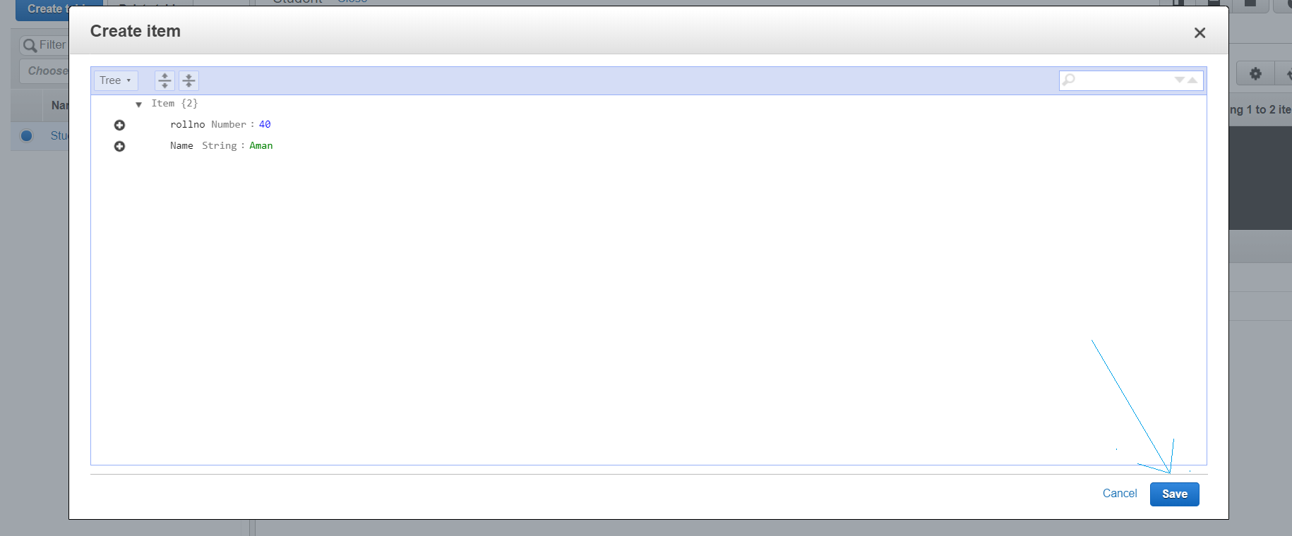

**Step 7:** Now in the “Student” table the query the rollnumber 20 as shown in the following windows. Select the Query option as shown in the window below

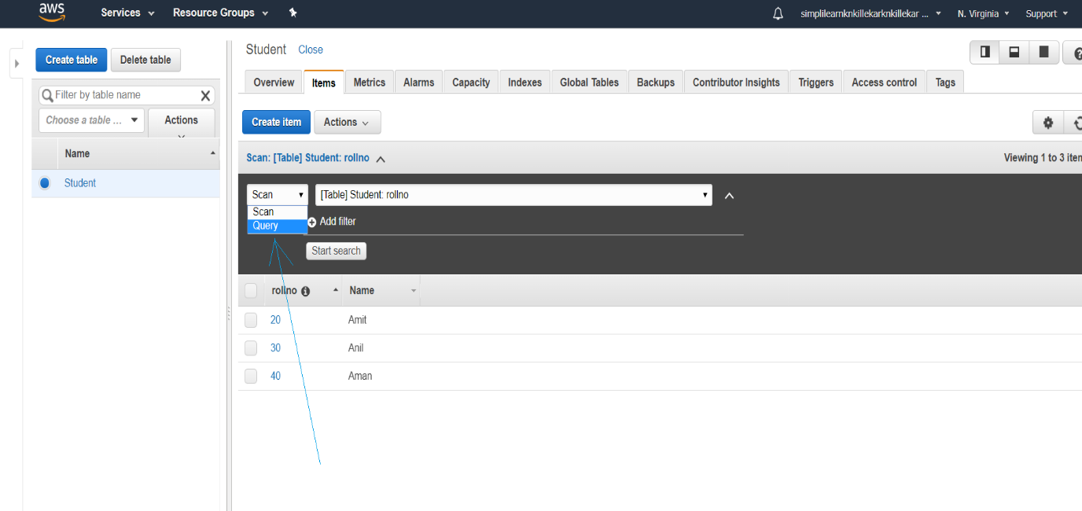

**Step 8:** Next, enter the query the rollnumber 20 as shown the below.

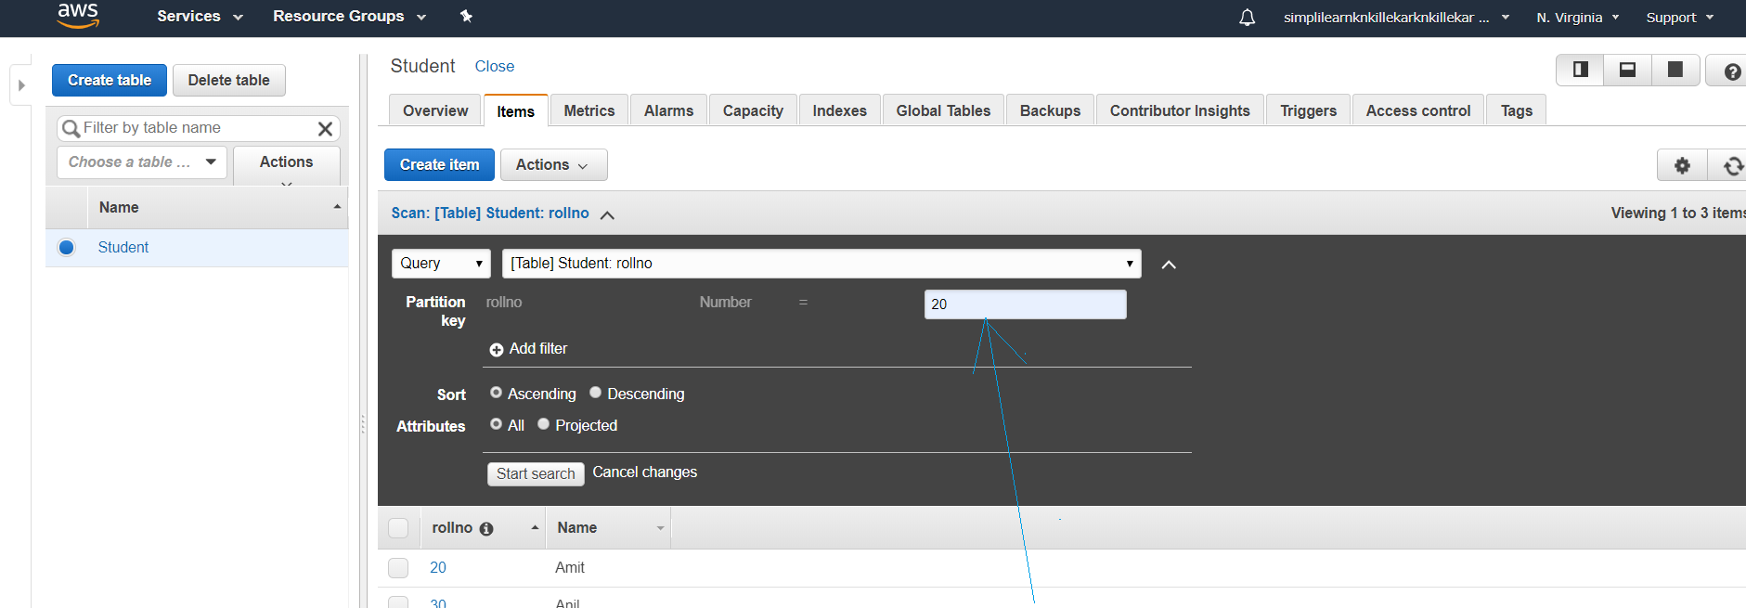

**Step 9:** Next, click on Start search option to get the required result as shown below.

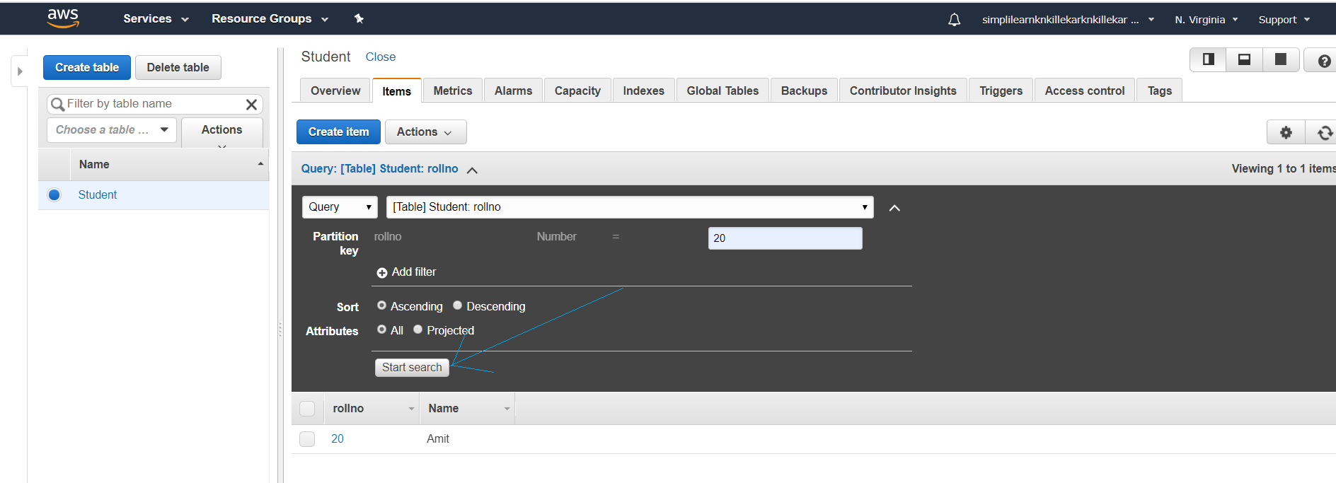

**Step 10:** To delete the table “Student” click on delete table option as shown in the window below.

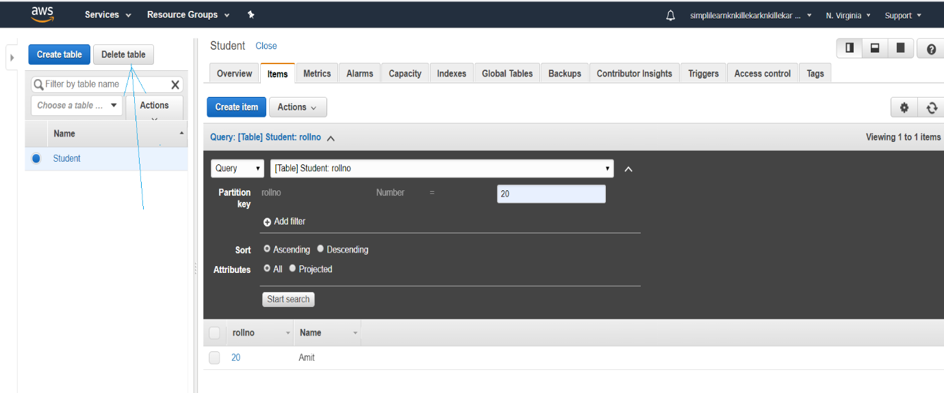

A popup window will appear and click on delete option as shown in window below.

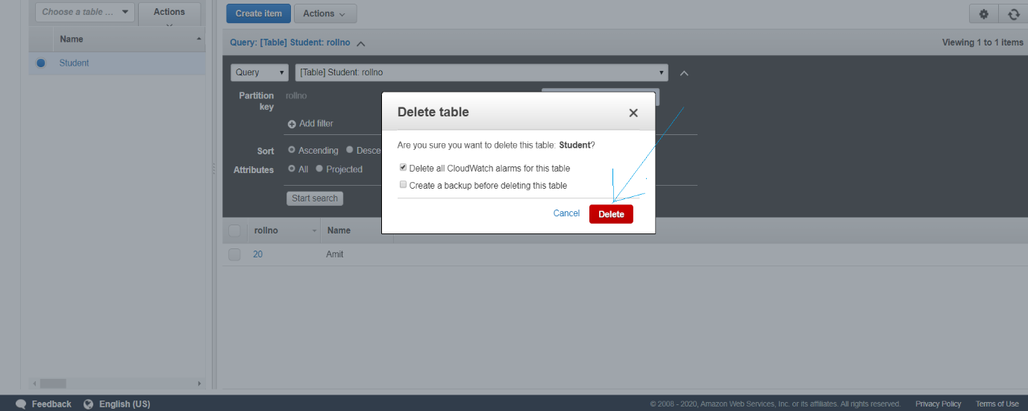

The table “ Student” is deleted successfully as shown in the window below.

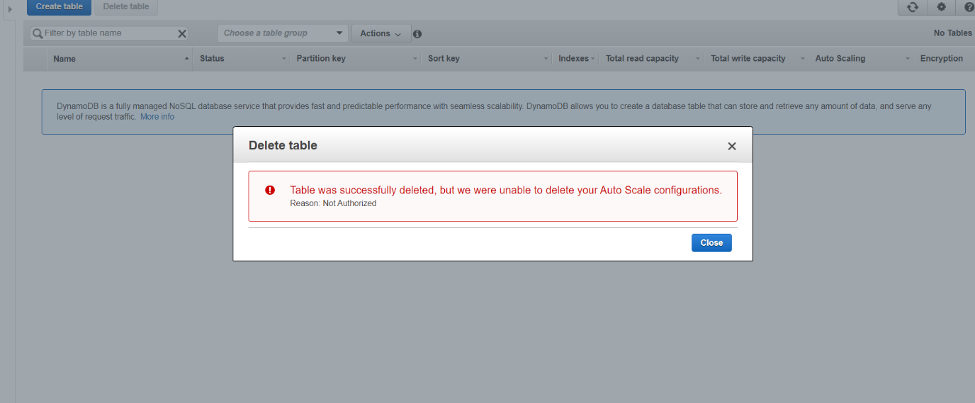

**-----------------------------------------------END-----------------------------------------------------------**